Congratulations! - Special Commendation Award

**Mentoring**

**From:**mentoring@aston.ac.uk

**To:**asonjude@yahoo.co.uk

Thu, Jun 8, 2023 at 9:46 a.m.

Hi Jude

I hope you are well I just want to say a big Congratulations! You are the winner of the award of Special Commendation.

Whilst you were nominated by one of your mentees, I wanted to give you this award personally from the team as I believe you have shown an exceptional dedication to the scheme and supporting other students. Thank you for your help with supporting the training last year and I could see from the effort you put into organising your mentee sessions that you really went above and beyond. A huge well done from all of the team Jude!

Please find your winners certificate attached. The LDC admin team will be in touch soon with your prize voucher.

Kind Regards

**Sara Rai Kullar**  
Student Transition Officer

Learning Development Centre, L121  
Birmingham, B4 7ET, UK  
0121 204 3226

[s.kullar@aston.ac.uk](mailto:s.kullar@aston.ac.uk)  
[**www.aston.ac.uk**](http://www.aston.ac.uk/)

**FOUNDATIONS OF MENTORING CERTIFICATE**

**VERIFICATION AT** [**https://thementoracademy.thinkific.com/certificates/sfiohbyv7x**](https://thementoracademy.thinkific.com/certificates/sfiohbyv7x)

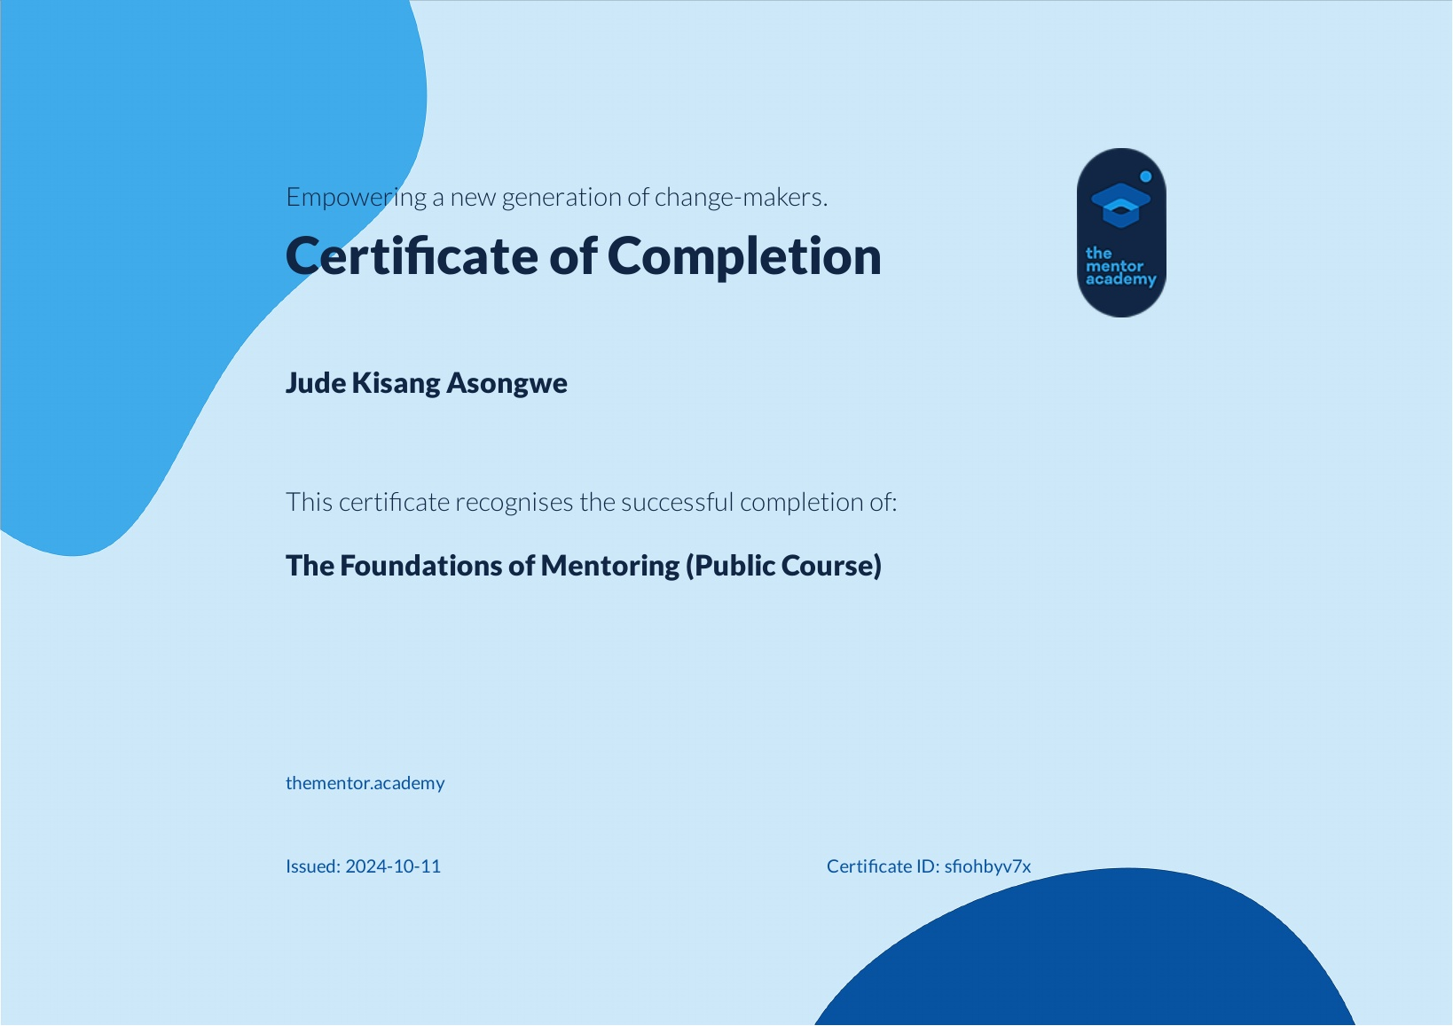

**MENTORCRUISE**

[**https://mentorcruise.com/mentor/judekisang-asongwe/**](https://mentorcruise.com/mentor/judekisang-asongwe/)

# **Welcome to MentorCruise.com**

Welcome to MentorCruise.com

**Dominic Monn**

**From:**dom@mentorcruise.com

**To:**judekisangasongwe@gmail.com

Wed, 2 Oct at 09:48

Hey Jude,

I'd like to wish you a warm welcome to MentorCruise. We're excited to have you on board and can't wait to see you grow even further as a mentor.

Looking forward to seeing you on the platform!

Best,  
Dominic Monn  
Founder, MentorCruise